# Table content

1. **Project Goal**
2. **Project Objectives**
3. **Project Scope**

* **Project in Scope**
* **Target Language Platform**
* **Target Audience**
* **Out of Scope**

1. **Project Deliverable**

* **Analysis Document**
* **Design Documents**
* **User Documentation**
* **Quality Plan**
* **Project Executive**

1. **Resources**
2. **Project Milestone**
3. **Project Schedule**

# Project Proposal

# Project Introduction and Overview

Angelina owns a recruitment agency .She wants to increase her business by making a website so people can contact Angelina by a website.This website will help Angelina bring more people to her business .

|  |  |
| --- | --- |
| **NAME** | ANGELINA |
| **CONTACT** | 020646767557 |
| **ADDRESS** | 12 QUEEN STREETAUCKLAND |
| **E-MAIL** | ANGELINA007@gmail.com |

# Project Description

## Project Need

* Create a homepage .
* Create an admin panle
* Create a form where people can add the information .

## Goals and Objectives

The main goal of this project is to attract people to Angelina ’s buisness. People can add there details on the website and send to Angelina .She can later see the information in the admin panel and contact them.

The website allows following features: -

* Can add information that is only seen by Angelina or her employers.
* Angelina can see the information and choose which people she want to add to the program.

## Languages used: -

* .Net framework
* C Sharp
* ASP.net
* Bootstrap
* MYSQL

## Target Audience

In the first pilot software, the target audience is: -

* Client: - can add the information which can be seen by the Angelina .
* Owner:- can view the information and choose which people to add .

## Out of Scope: -

* Can add a filter functionality in admin panel.
* Can add other pages that describe the buisness of Angelina.

## Project Deliverable: -

## Analysis Document: -

**Wireframe of About**

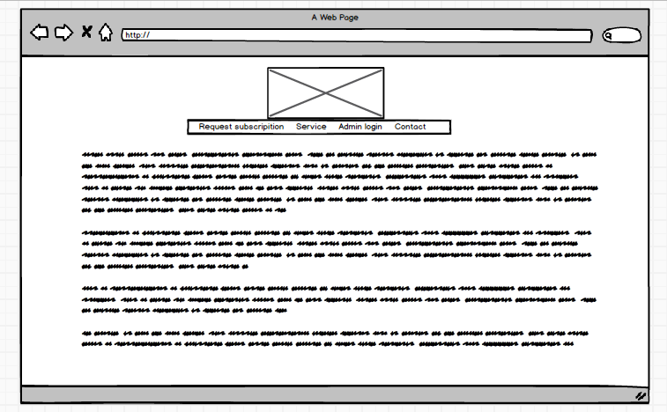

Request details

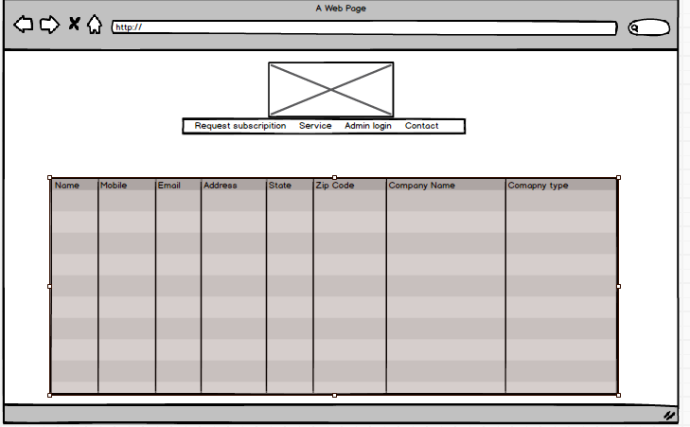

**Request subscription**

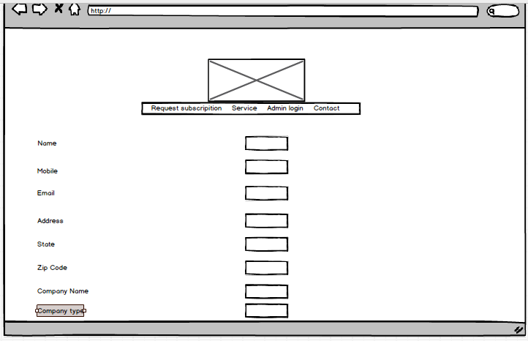

**Admin Login**

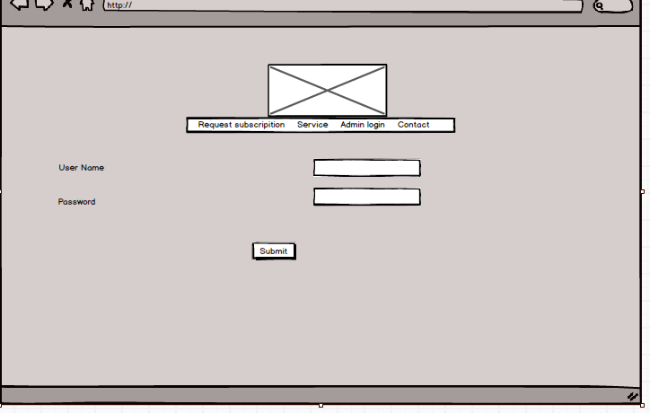

**wire**

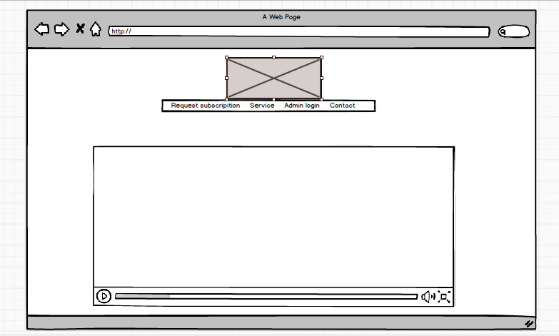

**Wireframe of Employee Enrolment**

**Mock-up of about page**

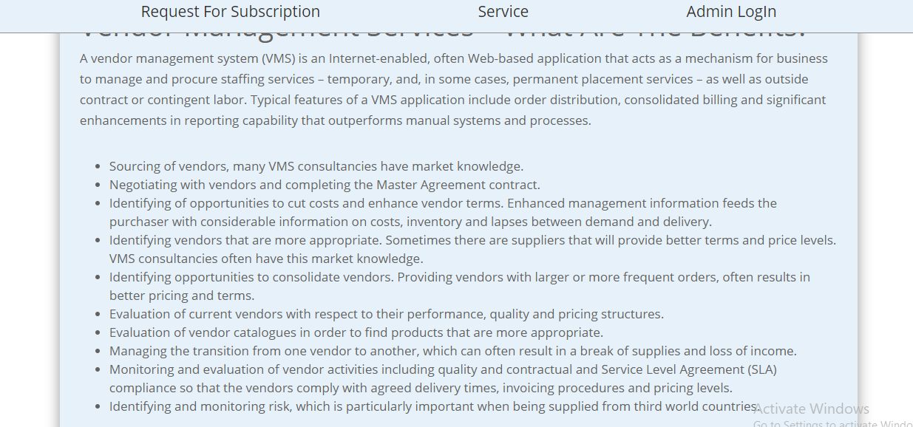

**Home page**

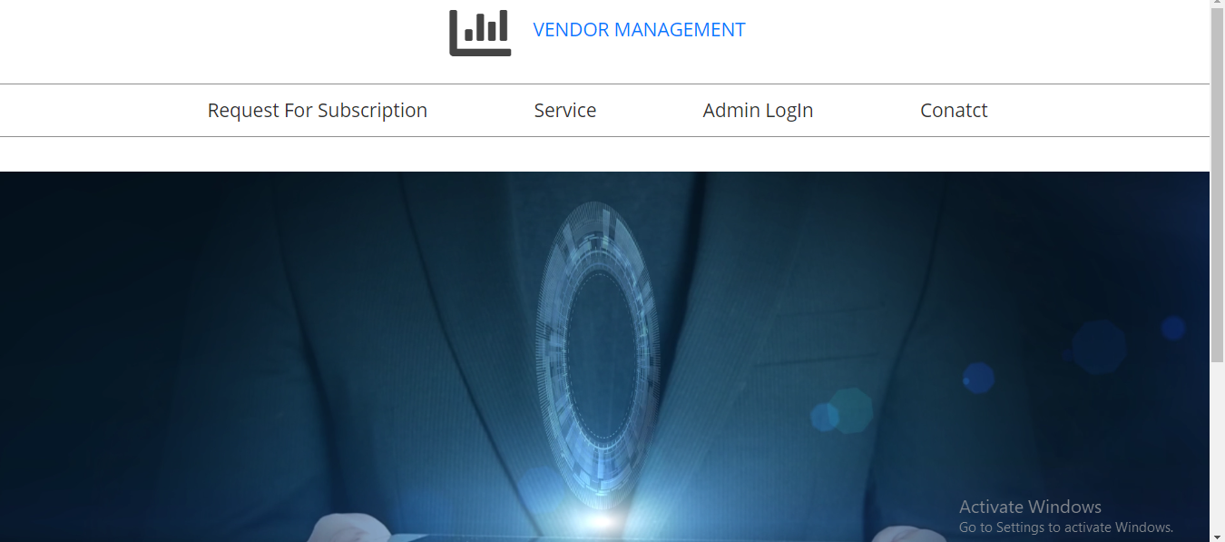

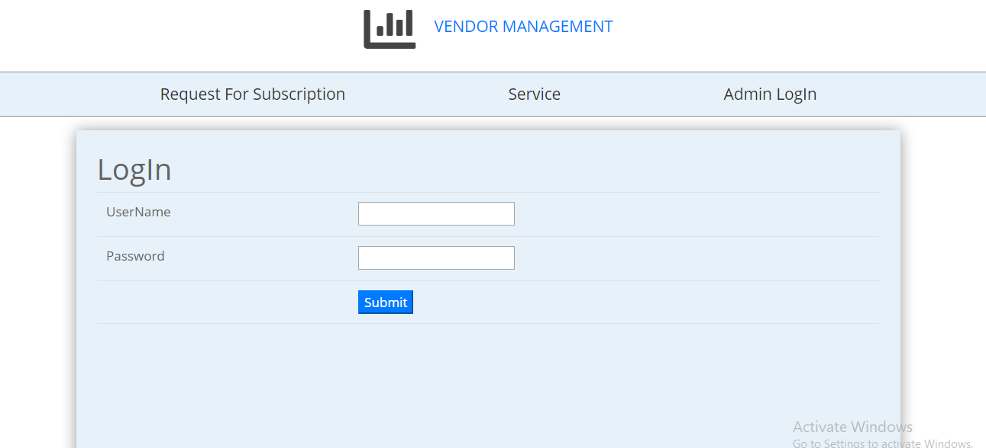

**Request subscription**

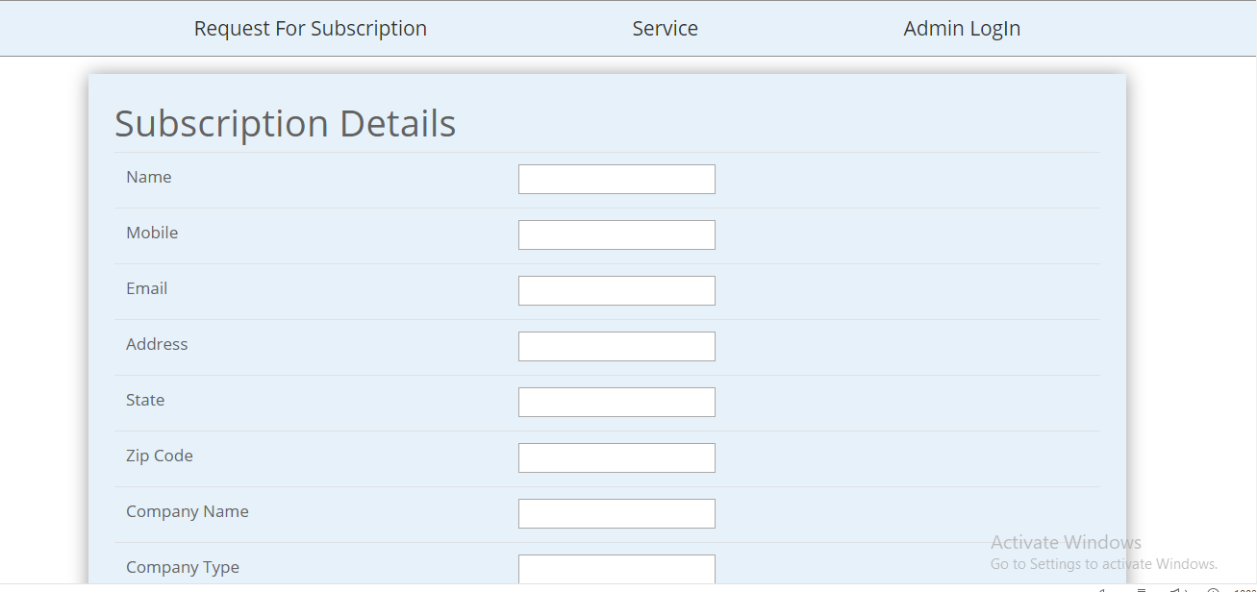

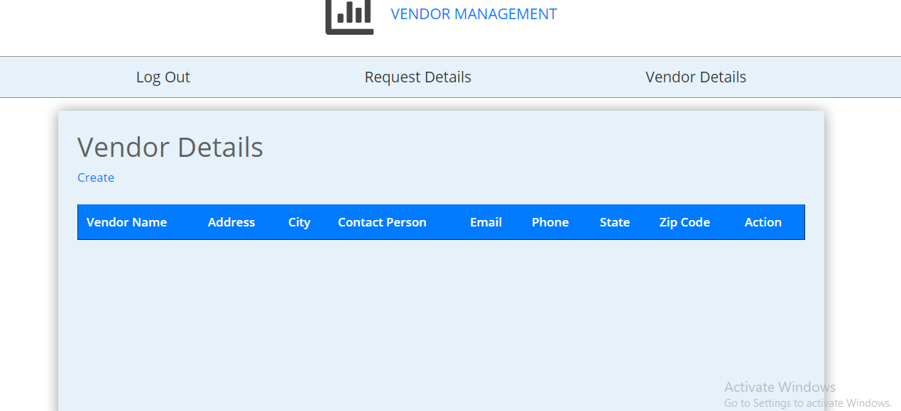

## Documentation: -

**Home Page:**

Home page is the main page of the website which includes further four pages request for subscription, Service, Admin login, contact respectively. The logo of VENDOR MANAGEMENT is placed at the top centre of the homepage. The website is fully responsive and functions correctly.



**Request description Page:**

In the following page the major details are asked for the subscription of the student. When we fill the details, the filled information is saved in admin log in. the form is designed for the professional look.



**Admin Login Page:**

**A form is provided which asks for user name and password for the login of admin. It will automatically takes the admin to the request details followed by the vendor details.**



**Service Page:**

The following page gives the brief detail of vendor management services which includes the information of all the benefits of this services and why a customer should hire this service.



**Office Address Page:**

Office address helps to record the all the address of the employees working in the company. Again, create button will appear below the menu bar. create button helps to create the data of the permanent address of every employee working in the company. Below is the screenshot:

**Vendor details Page:**

**The following page angelina can add the employees she wants to work with by clicking on the create button. The create button the will redirect the angelina to create page.**



## Quality Plan: -

|  |  |  |  |  |  |
| --- | --- | --- | --- | --- | --- |
| Step NO | Test Step | Input Data | Expected Result | Actual Result | Test Step Result |
| 1 | Add New subscription details | peter | On The Screen all details should appear | As Expected | Pass |
| 2 | Login system | vendor | Login feature should working | As Expected | Pass |
| 3 | Add vendor details | gill | Details About the vendor when created should be appear | As Expected | Pass |
| 4 | Delete Button in vendor detail page | rick | Admin can delete and edit the details | As Expected | Pass |
| 5 | Request subscription data show | ricky | Data should show in table | As Expected | Pass |

## Project executive summary: -

**Hardware: -**

* Windows 10
* Intel core processor i5
* 8GB RAM

**Software: -**

* Visual Studio 2017
* Microsoft SQL

**Languages: -**

* C Sharp
* jQuery
* ASP.Net
* SQL

## Resources: -

Requirements Required to complete this project are as follow:

* PC must have RAM of 8GB.
* Windows used should be Windows 10.
* At least Intel i5 Processor should be used.
* Visual Studio 2017 is Required for the coding.
* Microsoft SQL is required for establishing the database and for the connection between visual studio and database.
* C#, jQuery, bootstrap, HTML, NETFramwork, ASP, all of them should be used.

## Project Milestone: -

|  |  |
| --- | --- |
| **WORK** | **DAY** |
| Database | 10 April to 14 April |
| Controller | 14 April to 20 April |
| Front End | 20 April to 25 April |
| Back End Coding | 25 April to 29 April |
| Documentation | 29 April to 1 may |

## Project Schedule: -

|  |  |
| --- | --- |
| **WORK** | **HOURS** |
| **Database** | **7 hours** |
| **Controller** | **11 hours** |
| **Front End** | **12 hours** |
| **Back End Coding** | **17 hours** |
| **Documentation** | **2 hours** |